J.J.M.T
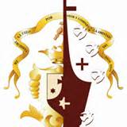

Our Congregation it was founded in Mexico City March 8th, 1903 by four brave women who were deeply in love with our Lord and determined to follow him radically as He showed them to.
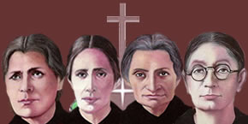
Our Foundress Mothers are: Teresa Pétrea de la Cruz, Carmen de San Eliseo, Soledad de la Pasión, and Antonia del Espíritu Santo.
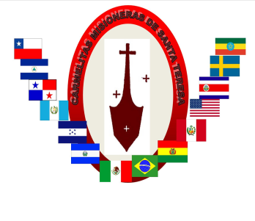
Our Congregation is organized in 4 provinces and 1 delegation and is currently present in 10 different countries; here in the United States with 11 apostolic works, Mexico 2 provinces with 36 apostolic works, Brazil 1 apostolic work, Bolivia and Peru with 6 apostolic works, El Salvador, Honduras, Guatemala with 17 apostolic works, Chile with 1apostolic work and Etheopia Africa with 1 apostolic work.
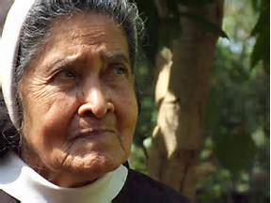
From the beginning our Congregation has been characterized by its search for authenticity of religious life committed to making present the Kingdom of God. We follow Christ in his trusting filial communication with the Father, this is why we have the mission to live and share our friendship with God through the giving of our life in simplicity, preferably among the poor.
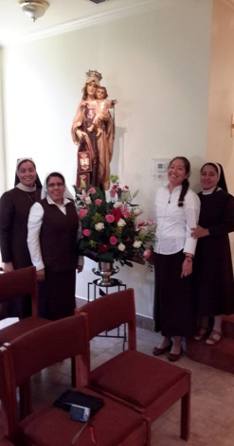
We have a very special devotion to our blessed Mother, particularly under the title of Our Lady of Mount Carmel. To us she is our Mother, Model, Friend and our Companion on our Christian journey. She is always a sign of hope in our search to live out an authentic religious life. We live the spirituality of St. Teresa of Avila and St. John of the Cross in the style of our Foundress Mothers, embracing the contemplative aspect as the fountain of our service to our brothers and sisters.

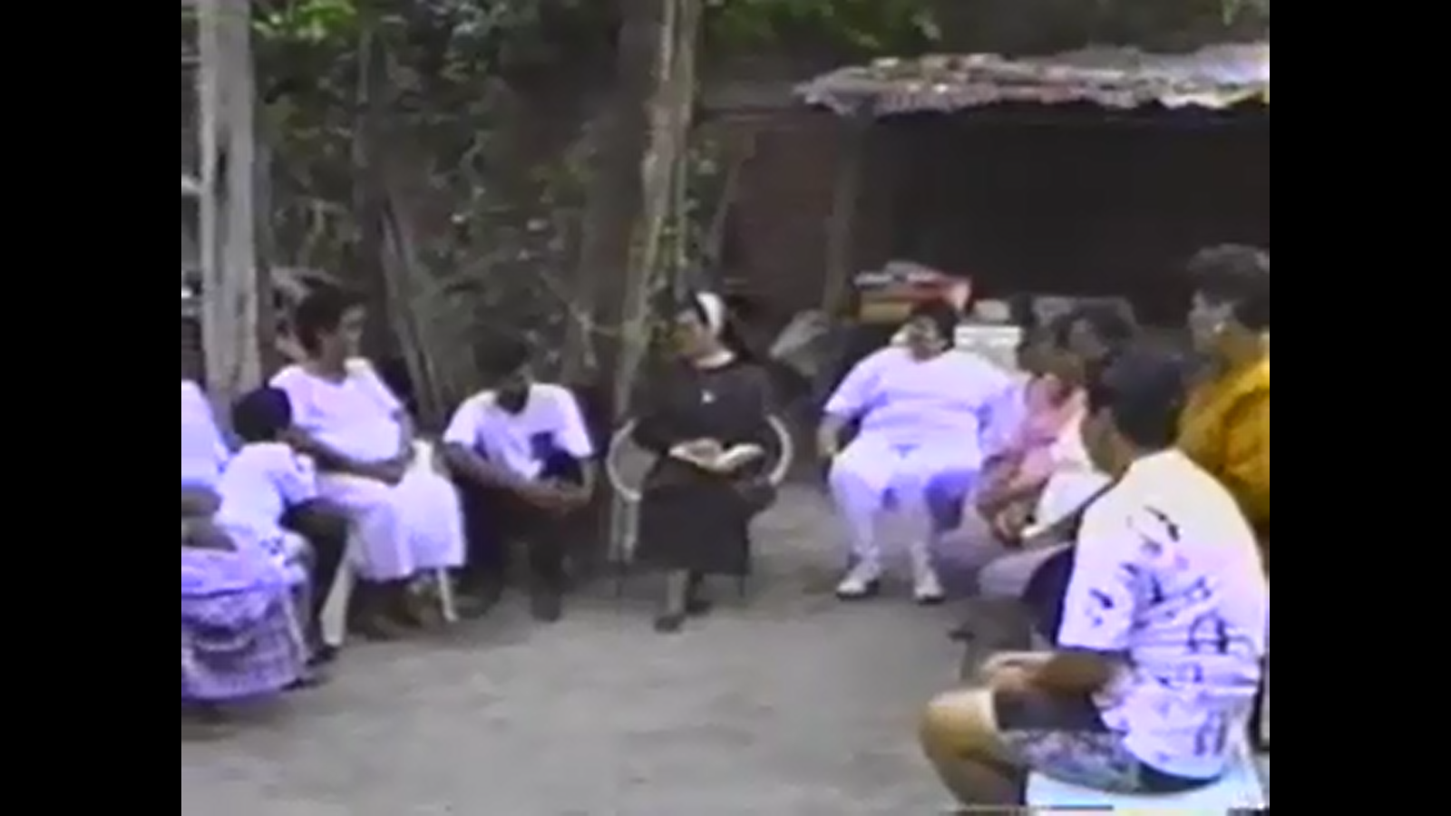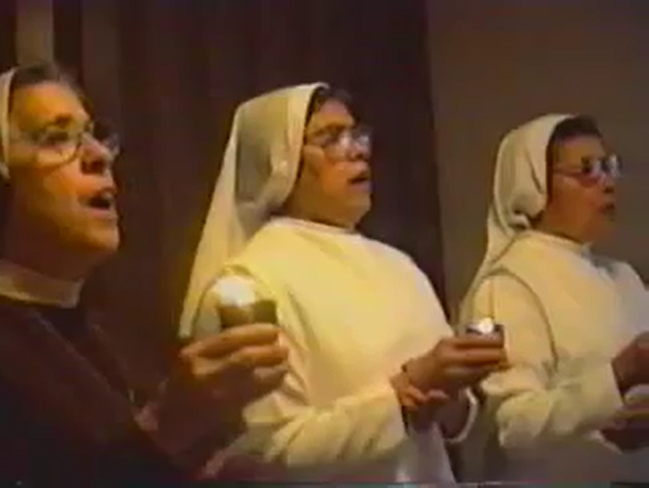

Our mission of evangelization has the objective of building the Kingdom of God. We accomplish this through the apostolates of: Education, Pastoral of Health, Missions, and Pastoral of Spirituality. We live our Missionary Carmelite vocation with a strong sense of fraternity, joy, simplicity, poverty, humility in truth, and apostolic abnegation as our Foundress Mothers lived it.
In order to serve the Church as a Missionary Carmelite of St. Teresa, a process of ongoing formation is required that responds to the needs of each sister, each community, and each place where we make an apostolic presence, bearing in mind that our main formator is the Holy Spirit.
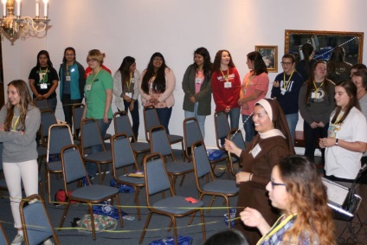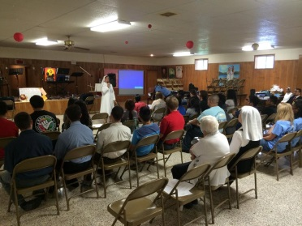
This process of formation begins with the vocation ministry. During this stage the young woman has the first contacts with the Congregation from her own environment. At the same time the Congregation knows and accompanies her personally or in groups and gives her an apostolic experience.
The next stage is the Postulancy, the stage of the initial formation in which the young woman has the experience of living in community in the Congregation, forming herself fully in order to clarify her motivations and acquire sufficient preparation to begin the stage of the Novitiate.
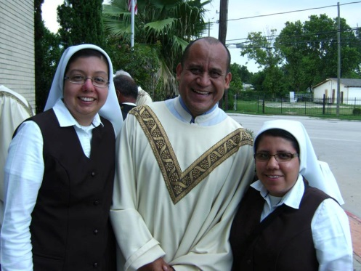
The Novitiate is the stage in which the sister in formation begins her religious life in the Congregation, through the continuous exercise of the life of contemplative prayer in silence and solitude, intimacy with Mary the experience of consecrated life, and the experience of evangelical counsels. During this stage the novice grows according to the experience of the founding charism and the spirit of St. Teresa of Jesus to later carry out the specific mission of the Institute: "To live the experience of God and to help others to live it through the simple delivery of our life preferably among the poor.”
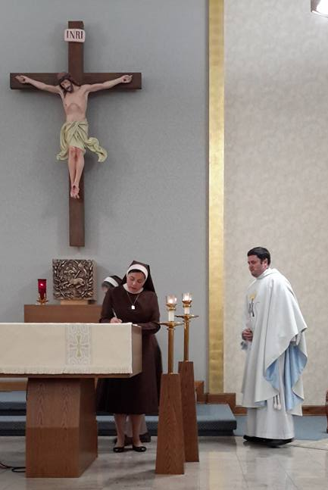
The Missionary Carmelite of St. Teresa lives the complete consecration to God for the following of Christ in the profession of vows of chastity, poverty, and obedience for the edification of the kingdom of justice, love and peace. This stage of formation is oriented to place God as the center of one's own existence, making contemplative prayer the fundamental project of life, the most authentic expression of which will be apostolic action. During the time of temporary vows the junior sister, engaged in the service of the brothers, is properly prepared to make her final consecration.
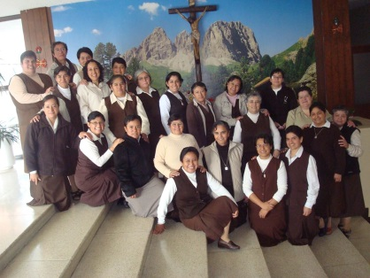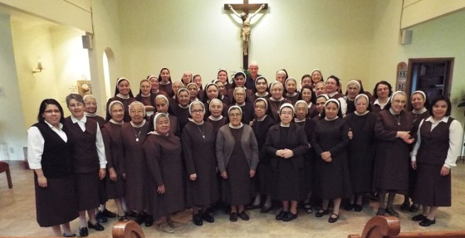
The formation of the Missionary Carmelite of Santa Teresa does not end with the initial stages but is continued throughout life; Living in a community of faith that seeks with openness and authenticity the meaning of events in the light of the word of God.
We live our vocation as Missionaries Carmelite of Saint Teresa in the spirit of sisterhood, joy, simplicity, humility in truth, poverty and apostolic self-denial as our Founding Mothers lived. Our Institute, faithful to the charism received, assumes all its values within a search for authenticity of religious life in continuous openness to the circumstances of life from a prayerful discernment in faith and active hope.
Today, Jesus continues to call generous young people to follow him and give his life to the service of others. You can be one of them. We invite you to live and share the friendship of the living God as a Missionary Carmelite of St. Teresa.

